 | 12.1.33 Editors - Geometry Nodes Editor - Header - Add Menu - Texture
Table of content
Detailed table of content 1
Add menu - Texture 4
Brick Texture 4
Checker Texture 5
Gradient Texture 6
Image Texture 7
Magic Texture 9
Musgrave Texture 10
Noise Texture 12
Voronoi Texture 13
Wave Texture 14
White Noise Texture 15

Detailed table of content
Detailed table of content
Detailed table of content 1
Add menu - Texture 4
Brick Texture 4
Inputs 4
Color 1, Color 2 and Mortar 4
Scale 4
Mortar Size 4
Mortar Smooth 4
Bias 5
Brick Width 5
Row Height 5
Properties 5
Offset 5
Frequency 5
Squash 5
Frequency 5
Outputs 5
Color 5
Factor 5
Checker Texture 5
Inputs 5
Vector 5
Color 1 6
Color 2 6
Scale 6
Properties 6
Gradient Type 6
Output 6
Color 6
Factor 6
Gradient Texture 6
Inputs 6
Vector 6
Properties 6
Gradient Type 6
Output 7
Factor 7
Color 7
Image Texture 7
Inputs 7
Image 7
Image Browser 7
New/Open 7
Image Edit Box 7
Fake User 7
New Image 7
Open Image 8
Remove 8
Vector 8
Frame 8
Properties 8
Interpolation 8
Linear 8
Closest 8
Cubic 8
Extension 8
Repeat 8
Extend 8
Clip 8
Outputs 8
Color 8
Alpha 9
Magic Texture 9
Inputs 9
Vector 9
Scale 9
Distortion 9
Properties 9
Depth 9
Outputs 9
Color 9
Factor 9
Musgrave Texture 10
Inputs 10
Vector 10
W 10
Scale 10
Detail 10
Dimension 10
Lacunarity 11
Offset 11
Gain 11
Properties 11
Dimensions 11
1D 11
2D 11
3D 11
4D 11
Type 11
fBM (fractal Brownian Motion) 11
Multifractal 11
Hybrid Multifractal 11
Ridged Multifractal 12
Hetero Terrain (Heterogeneous Terrain) 12
Outputs 12
Height 12
Noise Texture 12
Inputs 12
Vector 12
Scale 12
Detail 12
Roughness 12
Distortion 12
Properties 12
Dimensions 12
Output 12
Factor 12
Color 13
Voronoi Texture 13
Inputs 13
Vector 13
Scale 13
Randomness 13
Properties 13
Dimensions 13
Feature Output 13
F1 13
F2 13
Smooth F1 13
Distance to Edge 13
N-Sphere Radius 14
Distance Metric 14
Output 14
Factor 14
Color 14
Wave Texture 14
Inputs 14
Vector 14
Scale 14
Distortion 14
Detail 14
Detail Scale 14
Detail Roughness 14
Phase Offset 15
Properties 15
Wave Type 15
Bands direction 15
Wave Profile 15
Saw 15
Sine 15
Triangle 15
Outputs 15
Color 15
Factor 15
White Noise Texture 15
Inputs 15
Vector 15
Properties 16
Gradient Type 16
Output 16
Vector 16
Color 16

Add menu - Texture
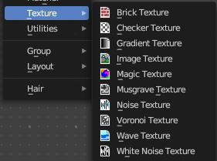
Texture nodes.

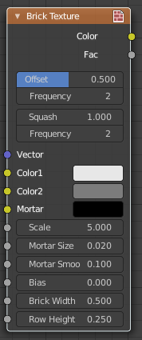
Brick Texture
The Brick Texture node is used to add a procedural brick texture.

Inputs

Color 1, Color 2 and Mortar
Color of the bricks and mortar.

Scale
Overall texture scale.

Mortar Size
The size of the filling between the bricks known as “mortar”; 0 means no mortar.

Mortar Smooth
Blurs/softens the edge between the mortar and the bricks. This can be useful with a texture and displacement textures.

Bias
The color variation between Color 1/2. Values of -1 and 1 only use one of the two colors; values in between mix the colors.

Brick Width
The width of the bricks.

Row Height
The height of the brick rows.

Properties

Offset
Determines the brick offset of the various rows.

Frequency
Determines the offset frequency. A value of 2 gives an even/uneven pattern of rows.

Squash
Amount of brick squashing.

Frequency
Brick squashing frequency.

Outputs

Color
Texture color output.

Factor
Mortar mask (1 = mortar).

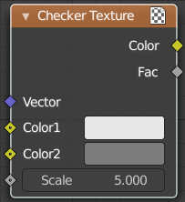
Checker Texture
Adds a checker texture.

Inputs

Vector
Vector input.

Color 1
The first checker color.

Color 2
The second checker color.

Scale
The scale of the checker texture.

Properties

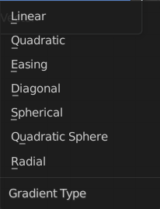
Gradient Type
What gradient type to use.

Output

Color
The checker texture output.

Factor
Factor output.

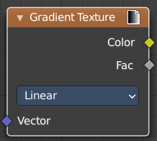
Gradient Texture
Add a gradient texture.

Inputs

Vector
Vector input.

Properties

Gradient Type
What gradient type to use.

Output

Factor
Factor output.

Color
Color output.

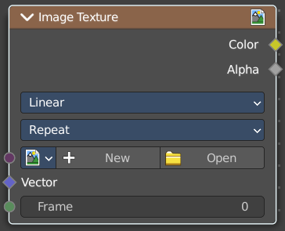
Image Texture
The Image Texture is used to add an image file as a texture.

Inputs

Image
The Image input. Open an image, choose an existing image, or generate a new image.
When you click at Open then a file browser opens up. When you click at New then a popup dialog opens. up where you can create a new image.

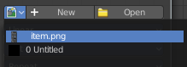
Image Browser
The image browser at the left allows you to pick an already existing texture.

New/Open
Create a new image, or open an image.

Image Edit Box
The name of the image.

Fake User
Keep the texture in the blend file even if it is not used.

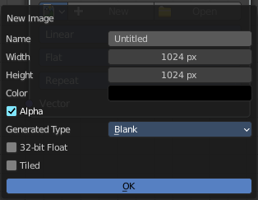
New Image
Create a new image.
The settings of this image can be further adjusted in the sidebar of the UV Editor.

Open Image
Open an image.

Remove
Remove the image. Note that it is still in the blend file as long as it has users, and as long as you haven't purged it. By saving and reloading the blend file for example.

Vector
Texture coordinate for texture look-up. If this socket is left unconnected, UV coordinates from the active UV render layer are used.

Frame
The frame of an image sequence, if available.

Properties

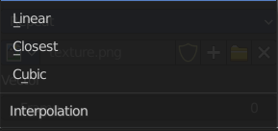
Interpolation
Method to scale images up or down for rendering.

Linear
Regular quality interpolation.

Closest
No interpolation, use only closest pixel for rendering pixel art.

Cubic
Smoother, better quality interpolation. For bump maps this should be used to get best results.

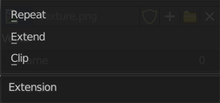
Extension
Extension defines how the image is extrapolated past the original bounds:

Repeat
Will repeat the image horizontally and vertically giving tiled-looking result.

Extend
Will extend the image by repeating pixels on its edges.

Clip
Clip to the original image size and set all the exterior pixels values to transparent black.

Outputs

Color
RGB color from image. If the image has alpha, the color is premultiplied with alpha if the Alpha output is used, and unpremultiplied or straight if the Alpha output is not used.

Alpha
Alpha channel from image.

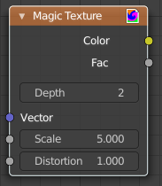
Magic Texture
The Magic Texture node is used to add a procedural psychedelic color texture.

Inputs

Vector
Texture coordinate to sample texture at; defaults to Generated texture coordinates if the socket is left unconnected.

Scale
Scale of the texture.

Distortion
Amount of distortion.

Properties

Depth
Number of iterations.

Outputs

Color
Texture color output.

Factor
Texture intensity output.

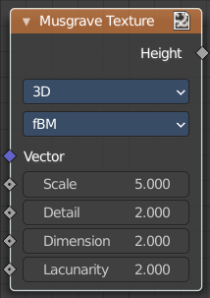
Musgrave Texture
The Musgrave Texture node evaluates a fractal Perlin noise at the input texture coordinates. Compared to the noise texture, the Musgrave Texture allows greater control over how octaves are combined.

Inputs
The available input types change, dependent of the chosen Type and dimensions.
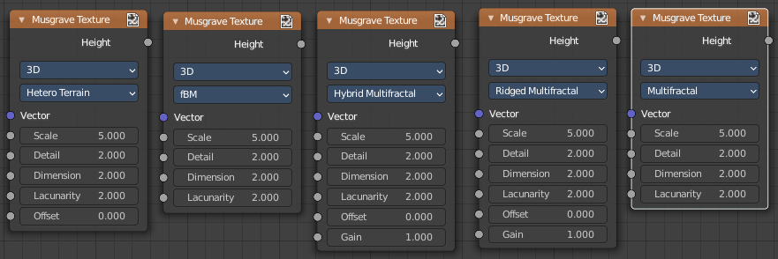

Vector
Texture coordinate to evaluate the noise at. Defaults to Generated texture coordinates if the socket is left unconnected.

W
Texture coordinate to evaluate the noise at. Appears with 4 dimensions.

Scale
Scale of the base noise octave.

Detail
Number of noise octaves. The fractional part of the input is multiplied by the magnitude of the highest octave. Higher number of octaves corresponds to a higher render time.

Dimension
The difference between the magnitude of each two consecutive octaves. Larger values corresponds to smaller magnitudes for higher octaves.

Lacunarity
The difference between the scale of each two consecutive octaves. Larger values corresponds to larger scale for higher octaves.

Offset
An added offset to each octave, determines the level where the highest octave will appear.

Gain
An extra multiplier to tune the magnitude of octaves.

Properties

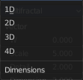
Dimensions
The dimensions of the space to evaluate the noise in.

1D
Evaluate the noise in 1D space at the input W.

2D
Evaluate the noise in 2D space at the input Vector. The Z component is ignored.

3D
Evaluate the noise in 3D space at the input Vector.

4D
Evaluate the noise in 4D space at the input Vector and the input W as the fourth dimension.

Higher dimensions corresponds to higher render time, so lower dimensions should be used unless higher dimensions are necessary.

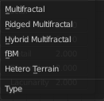
Type
Type of the Musgrave texture.

fBM (fractal Brownian Motion)
Produces an unnatural homogeneous and isotropic result. Uses an additive cascade, the values are simply added together.

Multifractal
The result is more uneven (varies with location), more similar to a real terrain. Uses a multiplicative cascade.

Hybrid Multifractal
Creates peaks and valleys with different roughness values, like real mountains rise out of flat plains. Combines the additive cascade with a multiplicative cascade.

Ridged Multifractal
Creates sharp peaks. Calculates the absolute value of the noise, creating “canyons”, and then flips the surface upside down.

Hetero Terrain (Heterogeneous Terrain)
Similar to Hybrid Multifractal creates a heterogeneous terrain, but with the likeness of river channels.

Outputs

Height
Greyscale texture output.

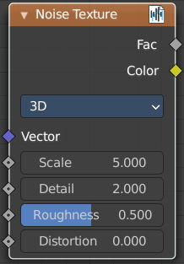
Noise Texture
Add a noise texture.

Inputs

Vector
Vector input

Scale
The scale of the noise texture.

Detail
The detail of the noise texture.

Roughness
The roughness of the noise texture.

Distortion
The distortion of the noise texture.

Properties

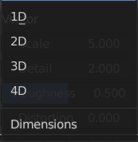
Dimensions
How many dimensions to use for the noise texture.

Output

Factor
Factor output.

Color
Color output.

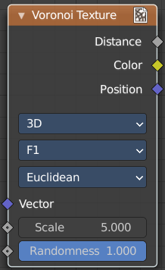
Voronoi Texture
Add a voronoi texture.

Inputs

Vector
Vector input

Scale
The scale of the voronoi texture.

Randomness
The detail of the voronoi texture.

Properties

Dimensions
How many dimensions to use for the voronoi texture.

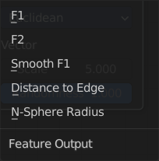
Feature Output
Feature output mode.

F1
Computes the distance to the closest point as well as its position and color.

F2
Computes the distance to the second closest point as well as its position and color.

Smooth F1
Smoothed version of F1.Weighted sum of neighbor voronoi cells.

Distance to Edge
Computes the distance to the edge of the voronoi cell.

N-Sphere Radius
Computes the radius of the n-sphere inscribed in the voronoi cell.

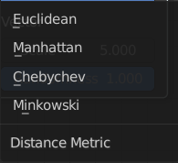
Distance Metric
Distance calculation mode. The modes are different mathematical methods.

Output

Factor
Factor output.

Color
Color output.

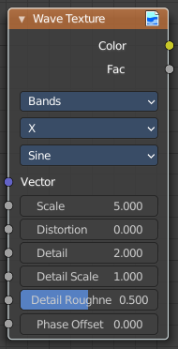
Wave Texture
The Wave Texture node adds procedural bands or rings with noise distortion.

Inputs

Vector
Texture coordinate to sample texture at; defaults to Generated texture coordinates if the socket is left unconnected.

Scale
Overall texture scale.

Distortion
Amount of distortion of the wave (similar to the Marble texture in Blender Internal).

Detail
Amount of distortion noise detail.

Detail Scale
Scale of distortion noise.

Detail Roughness
Adds a roughness noise.

Phase Offset
Set an offset for the phase.

Properties

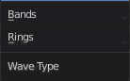
Wave Type
Bands or Rings shaped waves.

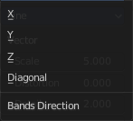
Bands direction
In which direction the bands should point.

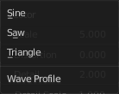
Wave Profile
Controls the shape and look of the wave type.

Saw
Uses a saw tooth profile.

Sine
Uses the standard sine profile.

Triangle
Uses a triangle shape.

Outputs

Color
Texture color output.

Factor
Texture intensity output.

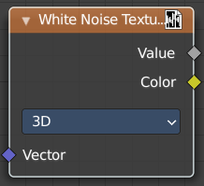
White Noise Texture
Add a white noise texture.

Inputs

Vector
Vector input.

Properties

Gradient Type
What gradient type to use.

Output

Vector
Factor output.

Color
Color output.

